Q 1: Briefly note on BCH code and its working.
• BCH … Discoverer: Bose, Chaudhuri and Hocquenghem.
• Multiple error correcting codes
• Generalization of Hamming Code.
• Flexibility in choice of parameters: Block length, code rate
• For positive pair of integers m and t, a (n, k) BCH code has parameters:
Block length: n = 2m – 1
Number of check bits: n – k <= mt
Minimum distance:dmin >= 2t + 1
• Correct combinations of t or fewer errors
• The generator polynomial can be constructed from the factors of (X^{2m-1} +1)
Q 2: Write down the classes of A/Gb mode of GPRS.
• Class A: MS can operate simultaneous packet switched and circuit switched services.
• Class B: MS can operate either one at one time – Most common for handsets today.
• Class C: MS can operate only packet switched services – e.g. Expansion cards for laptops.
Q 3: How MULTIMEDIA further divides in UMATS types?
Service classes in UMTS
• In 3G network, ME will be able to establish multiple connections simultaneously.
• Network allows efficient cooperation between application with diverse quality of service requirements.
• The quality can be defined by two main parameters
Guaranteed and max bit rate possible (kbps)
Permissible delay (ms)
Based on the QoS criteria, multimedia services has been further classified
• Conversational: The most delay sensitive, e.g. applications video telephony, VoIP
• Streaming: Flow which is steady and continuous, it is server to user
• Interactive: Web browsing is an example. A user may request timetables of buses, trains or flight schedule
• Background: Short messages, file transfer, email that has least stringent requirements of QoS
Q 4: Write down a note on HSCSD.
• Works in circuit switch mode.
• Speed increased by allowing single user to use consecutive time slots in GSM standard
• Relaxes error control coding algorithms specified in GSM increasing data rate from 9.600 to 14.400 Kbps
• By using 4 slots, raw data rate of up to 57.6 kbps to individual user.
• Ideal for dedicated streaming or real-time interactive web sessions
Q 5: Write brief note on EDGE.
• EDGE2.75G More advanced upgrade to 2G that requires addition of new hardware and software
• Developed as a path to become eventual 3G high speed data access
• New modulation 8-PSK in addition to GSM standard GMSK.
• Allows nine different formats known as Multiple modulation and Coding Scheme (MCS)
• Each MCS state may either use GMSK (low rate) or 8-PSK (high rate).
• A family of MCS for each GSM slot and users can adaptively determine best MCS setting
• User start first with max error protection and max data rate until the link has unacceptable outage or delay
• By combining different channels (multi-carrier trans), EDGE provides upto several megabits per second data throughput.
Q 6: Issues regarding handoff in interSystem.
If a mobile moves from one cellular system to a different system controlled by a different MSC
Issues to be addressed
- A local call becomes a long-distance call (roaming)
- Compatibility between two MSC must be determined
- Different systems have different policies and methods for managing handoff requests
Q 7: Write about QoS profile in GPRS bearer
QoS Profile for GPRS Bearers
4 parameters:
- Service precedence: 3 classes
- Reliability parameter: 3 classes
- Delay parameters: 4 classes
- Throughput parameter: Maximum and mean bit rates
QoS profile is included in Packet Data Protocol (PDP) context
Negotiation managed through PDP procedures (activation, modification and deactivation)
Q 8: Describe about Call routing in GSM network with Detailed diagram
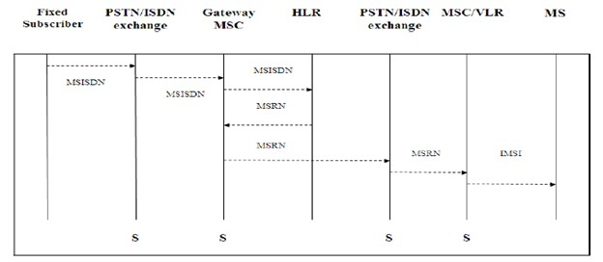
Q 9: Ad-Hoc vs Cellular Networks
Cellular Networks | Ad Hoc Wireless Networks
Fixed infrastructure-based | Infrastructure less
Guaranteed bandwidth (designed for voice traffic) | Shared radio channel (more suitable for best-effort data traffic)
Centralized routing | Distributed routing
Circuit-switched (evolving toward packet switching) | Packet-switched (evolving toward emulation of circuit switching)
Seamless connectivity (low call drops during handoffs) | Frequent path breaks due to mobility
High cost and time of deployment | Quick and cost-effective deployment
Reuse of frequency spectrum through geographical channel reuse | Dynamic frequency reuse based on carrier sense mechanism
Easier to employ bandwidth reservation | Bandwidth reservation requires complex medium access control protocols
Application domains include mainly civilian and commercial sectors | Application domains include battlefields, emergency search and rescue operations, and collaborative computing
High cost of network maintenance (backup power source, staffing, etc.) | Self-organization and maintenance properties are built into the network
Mobile hosts are of relatively low complexity | Mobile hosts require more intelligence (should have a transceiver as well as routing/switching capability)
Major goals of routing and call admission are to maximize the call acceptance ratio and minimize the call drop ratio | Main aim of routing is to find paths with minimum overhead and also quick reconfiguration of broken paths
Widely deployed and currently in the third generation of evolution | Several issues are to be addressed for successful commercial deployment even

Q 10: Why min rate of call is different from traffic density?
The handover area is usually an intersection of two adjacent and overlapping radio cells generated by the handover hysteresis. Altering the handover hysteresis ∆HO [dB] affects the users at the borders of the two adjacent cells and results in a change of cell dwell time and handover rates. The effect is that some users in the low density radio cell delay their handover to the high density cell, whereas users in the high density cell change earlier to the low density cell. If one handover hysteresis becomes negative, an area is formed where new calls meet the handover criterion and are booked to the neighboring cell immediately. This extreme case leads to a high increase in the handover rate and could also be modeled as an increase in the new call rate in the neighboring cell.
Q 11: Describe two reasons why ISM band is internationally beneficial?
• Industrial Scientific and Medical (ISM) band.
• Because WLANs, IEEE 802.11, Wireless PAN all operate on this band.
• The most widely adopted standard
Q 12: What are the reasons of call dropping?
• Excessive delay by MSC due to high traffic load
• ∆ is set too small for handoff time
• No channels are available on any of nearby BS
Q13: Explain IS-95 Reverse Link.
• Consists of upto 94 logical channels each occupying same bandwidth of 1228 KHz.
• It supports 32 access channels and 62 traffic channels
• Access channel is used to initiate a call, to respond to paging channel and for location update
• In reverse, convolutional encoder has a rate of 1/3, thus trippling the effective rate to a max of 28.8 kbps
Q14: Write two disadvantages of ALOHA.
• Low throughput under heavy load conditions
• Probability of collision increases as number of users increases
Q 15: Write difference between Periodic and Aperiodic signals.
• Periodic signal - analog or digital signal pattern that repeats over time
s(t +T ) = s(t ) - ∞< t < + ∞
where T is the period of the signal
• Aperiodic signal - analog or digital signal pattern that doesn't repeat over time
Q16: Reed-Solomon Codes.
• Subclass of non-binary BCH codes
• Data processed in chunks of m bits, called symbols
• An (n, k) RS code has parameters:
Symbol length: m bits per symbol
Block length: n = 2m – 1 symbols = m(2m – 1) bits
Data length: k symbols
Size of check code: n – k = 2t symbols = m(2t) bit
Minimum distance: dmin = 2t + 1 symbols
Q 17: Cell Splitting VS Cell clustering
Cell Splitting: When the number of users reaches saturation in a start-up cell (initial design) and no more spare frequency is available, then the start-up cell is split, usually in four smaller cells and traffic increases by four and more number of subscribers can be served.
CELL SPLITTING
- Achieve capacity improvement by decreasing R and keeping D/R (cell reuse ratio) unchanged
- Divide the congested cells into smaller cells
Smaller cells are called micro cells
- If radius of cell is cut to half, approximately four cells would be required
Increased number of cells would increase the number of clusters, which in turn increase the capacity
- Allows a system to grow by replacing larger cells with smaller cells without upsetting the allocation scheme CELL SECTORING
- Keep cell radius unchanged and decrease D/R
- Increases SIR so that cluster size may be reduced
SIR is improved using directional antennas
Hence increasing frequency reuse without changing transmission power
- Cell is partitioned into 3 120o sectors or 6 60o sectors as shown in Fig
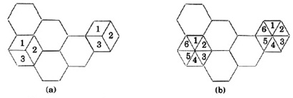
a) 120 degree sectoring b) 60 degree sectoring
MICROCELL ZONES
  - A cell is divided into zones with a single BS sharing the same radio equipment
  - Zones are connected through coaxial cable, fiber optics or microwave links to the BS
  - Superior to sectoring since antennas are placed at outer edges of the cells and any channel may be assigned to any zone by BS
  - As mobile travels from one zone to other, it retains same channel, BS simply switches the channel to a different zone.
  - Co-channel interference is minimized because,
Large BS is replaced by several low powered tx
Improves S/I
Q 18: What is the difference between the baseband signal and bandpass signal?
Baseband Signal
• Obtained by converting analog or digital data into analog or digital signal,
bandwidth = [0, fmax)
Bandpass Signal
• Band-limited signal whose minimum frequency is different from zero,
bandwidth = [f1, f2)
Q 19: Enhanced data rate for GSM evolution.
• GPRS data rates still fall short compared to that promised by 3G.
• The delay in deployment of 3G technology led to the emergence of EDGE
• Phase 1 (Release’99 & 2002 deployment) supports best effort packet data at speeds up to about 384 kbps
• Phase 2 (Release’2000 & 2003 deployment) will add Voice over IP capability
Q 20: List GPRS Channels and Describe Logical Channels.
Physical Channels
• Defined by timeslot (0-7) and radio frequency channel
• Shared Basic Physical Sub Channel
Shared among several users (up to 8)
• Dedicated Basic Physical Sub Channel: One user
• Packet Data Channel (PDCH)
Dedicated to packet data traffic from logical channels: Control, User data
Logical Channels
• Mapped by the MAC to physical channels
• Control channels for control, synchronization and signaling
Common, Broadcast, Dedicated
• Packet Traffic channels
Encoded speech, Encoded data
Q 21: What are the major characteristics of Ad-Hoc and future challenges?
• Heterogeneous nodes
• Self-creating: not rely on a pre-existing fixed infrastructure
• Self-organizing: no predetermined topology
• Self-administering: no central control
• Creating a network “on the fly”
Q 22: Give comparison of (802.11 vs 802.16).
• 802.11’s media access control protocol is optimized for shorter-range topologies
• It also was not designed to serve a large number of users
• Wireless MAN, on the other hand, was designed to solve the problems of delivering wireless broadband networks over longer distances and through more difficult environments, such as heavily wooded areas
Q 23: Give comparison of (802.11a vs 802.11b).
IEEE 802.11a
• Makes use of 5-GHz band
• Provides rates of 6, 9 , 12, 18, 24, 36, 48, 54 Mbps
• Uses orthogonal frequency division multiplexing (OFDM)
• Subcarrier modulated using BPSK, QPSK, 16-QAM or 64-QAM
IEEE 802.11b
• Provides data rates of 5.5 and 11 Mbps
• Complementary code keying (CCK) modulation scheme
Q 24: Give comparison of (Ad-hoc vs Cellular network).
Ad hoc networks
• Infrastructureless
• Multiple hop: Radio power limitation, channel utilization, and power-saving concerns
• DCF(distributed coordination function)
Cellular networks
• Infrastructure-based
• One hop(uplink or downlink)
• PCF(pointed coordination function)
Q 25: Define major capabilities for mobility in mobile ad hoc networks 802.15.
Q 26: What are the 802.16 burst types and downlink services?
Burst profiles
• Each burst profile has mandatory exit threshold and minimum entry threshold
• SS allowed to request a less robust DIUC once above the minimum entry level
• SS must request fall back to more robust DIUC once at mandatory exit threshold
• Requests to change DIUC done with DBPC-REQ or RNG-REQ messages
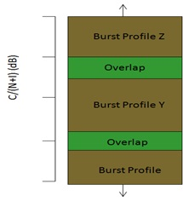
Downlink transmissions
• Two kinds of bursts: TDM and TDMA
• All bursts are identified by a DIUC: Downlink Interval Usage Code
• TDMA bursts have resync preamble: Allows for more flexible scheduling
• Each burst may contain data for several terminals
• SS must recognize the PDUs with known CIDs
• DL-MAP message signals downlink usage
Q 27: Give comparison of (Inter-mode vs intra-mode) in WCDMA.
Intra-Mode Handover
• Rely on the Ec/No measurement performed from the CPICH.
• The quantities defined that can be measured by the terminal from CPICH are
Received Signal Code Power (RSCP): received power on one code after de-spreading
RSSI: wideband received power within channel b/w
Ec/No, representing RSCP/RSSI
• Additional information for soft handover purposes is the relative timing between the cells to allow coherent combining in the RAKE receiver, otherwise would be difficult to combine.
If cells are within 10ms window, the relative timing can be found from primary scrambling code phase
Otherwise terminals need to decode System Frame Number from primary CCPCH that takes time and may suffer errors.
The 10 ms window has no relevance when timing information provided in neighboring cells list.
• For hard handover, timing info is not needed and different frequency measurements can be done with aid of compressed mode
Inter-Mode Handover
• Dual mode FDD-TDD terminals operating in FDD measure power level from TDD cells available
• The TDD CCPCH bursts sent twice during 10ms frame can be used for measurement.
• Since TDD cells are synchronized, finding one slot means that other TDD cells have roughly same timing for their burst.
• Terminal receives GSM synch channel during compressed frames in UTRA FDD.
• GSM 1800 set special requirements for compressed model
Q 28: Define major characteristics of Bluetooth.
Connection Type | Spread Spectrum (Frequency Hopping) & Time Division Duplex (1600 hops/sec)
Spectrum | 2.4 GHz ISM Open Band  (79 MHz of spectrum = 79 channels)
Modulation | Gaussian Frequency Shift Keying
Transmission Power | 1 mw – 100 mw
Data Rate | 1 Mbps
Range | 30 ft
Supported Stations | 8 devices
Data Security  Authentication Key | 128 bit key
Data Security  Encryption Key | 8-128 bits (configurable)
Module size | 9 x 9 mm

Q 29: Difference between Zigbee and Bluetooth.
IEEE standard: 802.15.1 - Bluetooth
• Topic: Bluetooth
• Data throughput: 1 Mbps
• Suitable applications: Cell phones, Computers, Personal Digital Assistants (PDAs)/ Handheld Personal Computers (HPCs), Printers, Microphones, Speakers, Handsets, Bar Code Readers, Sensors, Displays, Pagers and Cellular & Personal Communications Service (PCS) phones
• QoS needs: QoS suitable for Voice applications
IEEE standard: 802.15.4 - Zigbee
• Topic: Low-rate WPAN
• Data throughput: < 0.25 Mbps
• Suitable applications: Industrial, Agricultural, vehicular, Residential, Medical applications, Sensors and actuators with very low power consumption and low cost
• QoS needs: Relaxed needs for data rate and QoS
Q 30: Why do we need broadband wireless access, Give architecture diagram of WIMAX.
• Fill the gap between high data rate wireless LAN and very mobile cellular networks.
• Wireless alternative to cable and DSL for last-mile broadband access: Developing countries, Rural areas
• Provide high-speed mobile data and telecommunications services
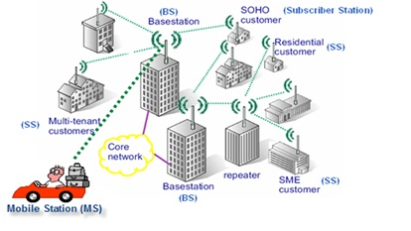
Q 31: S-MAC drawback in WSN.
• Active (Listen) interval – long enough to handle to highest expected load
If message rate is less – energy is still wasted in idle-listening
• S-MAC fixed duty cycle – is NOT OPTIMAL
• High Latency
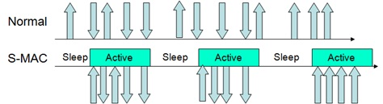
Q 32: What factors influencing in Sensor network designing?
Fault tolerance
• Fault tolerance is the ability to sustain sensor network functionalities without any interruption due to sensor node failures.
• The fault tolerance level depends on the application of the sensor networks.
Scalability
• Scalability measures the density of the sensor nodes.
• Density = μ(R) = (NπR2)/A
Production costs
• The cost of a single node is very important to justify the overall cost of the networks.
• The cost of a sensor node is a very challenging issue given the amount of functionalities with a price of much less than a dollar.
Hardware constraints
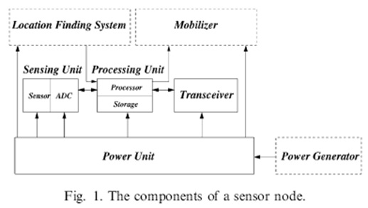
Sensor network topology
• Pre-deployment and deployment phase
• Post-deployment phase
• Re-deployment of additional nodes phase
Power consumption
• Sensing
• Communication
3000 instructions can be executed for the same energy cost of sending a bit 100m by radio.
Data processing
Q 33: Overview of WIMAX .
IEEE 802.16 Overview
• Family of standards for wireless metropolitan area networks (WMAN)
• Provide broadband (i.e., voice, data, video) connectivity
• Specifies the air interface, including the medium access control (MAC) layer and multiple physical layer specifications
• 802.16e is an amendment to 802.16d (fixed or nomadic wireless broadband) to support mobility
Vehicular speeds up to 75 mph
Q 34: WPAN support Contention based and contention free access, Write a Algorithm for both.
Q35: Discuss the current challenges in WSN?
• Cross-layer approach: A Grand Challenge
Traditional layered approach is not suitable for WSNs
Good for design, abstraction & debugging
Bad for energy efficiency, overhead & performance
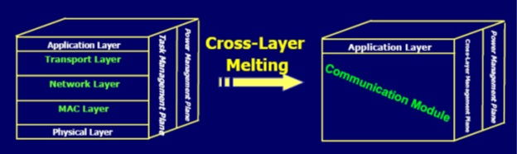
• How to realize mapping?
• User/Applications Requirements à
Arch. & Topology or Communication Protocols
E.g. reliability?
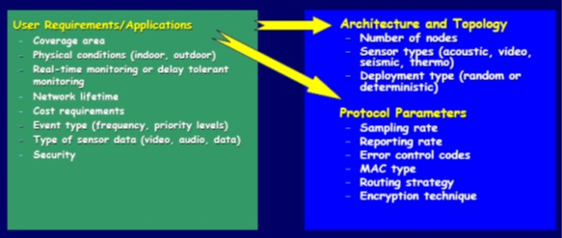
Q 36: Elaborate the compressed mode measurement and classify its methods?
Compressed Mode Measurements
• The compressed mode is needed when making measurement from another frequency without full dual receiver terminal.
• The intention is not to loose data but to compress
• The transmission and reception are halted for a short time to perform measurements on the other frequencies.
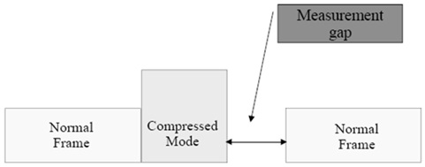
Three methods for compressed mode:
• Lowering the data rate from higher layers because they have knowledge of compressed mode schedule. dge of compressed mode schedule.
• the data rate by changing the spreading factor.
• Reducing the symbol rate by puncturing at the physical layer multiplexing chain but limited to rather short Transmission Gap Lengths (TGL).
• More power is needed during compressed mode.
• No power control during compressed mode. Large step size is used after a compressed frame to allow the power level to converge more quickly to the correct value after the break.
Q 37: Elaborate the critical factors influencing the network performance in WMN?
Radio techniques
• Directional and smart antennas
• MIMO systems
• Multi-radio chipsets
• More advanced techniques such as reconfigurable radios, cognitive radios
• These require revolutionary design changes in higher layers
Scalability
• Multihop routing is common in WMN, which degrades performance.
• IEEE 802.11 MAC is not scalable and throughput significantly reduces as number of hops increases to 4 or higher
Mesh connectivity
• Network self-organization and topology control algorithms are needed
Broadband and QoS
• Different from ad hoc networks, most applications of WMN are broadband services with various QoS requirements.
Compatibility and inter-operability
• Network access to both conventional and mesh clients
Security
• No centralized control
Ease of use
Q 38: Describe traffic adaptive MAC protocol with its advantages and disadvantages?
Traffic-Adaptive MAC (TRAMA)
• Time is divided into random-access and scheduled-access (transmission) periods.
• The random-access period is used to establish two-hop topology information
• MAC layer can calculate the transmission duration needed, which is denoted as SCHEDULE_INTERVAL
• the node calculates the number of slots for which it will have the highest priority among two-hop neighbors
• The node announces the slots it will use as well as the intended receivers for these slots with a schedule packet.
• The node announces the slots for which it has the highest priority but it will not use
• The schedule packet indicates the intended receivers using a bitmap whose length is equal to the number of its neighbors
Advantages
• Higher percentage of sleep time and less collision probability are achieved, as compared to CSMA-based protocols.
• Since the intended receivers are indicated by a bitmap, less communication is performed for the multicast and broadcast types of communication patterns, compared to other protocols.
Disadvantages
• Transmission slots are set to be seven times longer than the random-access period. This means that without considering the transmissions and receptions, the duty cycle is at least 12.5 percent (idle time),
Q 39: Discuss evolution of 4G with the help of diagram and discuss its issues?
Evolution of 4G
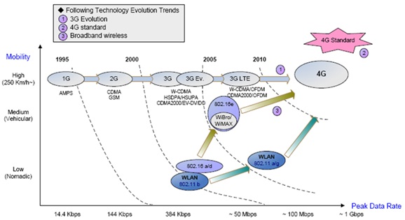
Need to resolve issues as
• Access
• Handoff
• Location coordination
• Resource coordination to add new users
• Support for multicasting
• Support for quality of service
• Wireless security and authentication
• Network failure and backup
• Pricing and billing.
Q 40: Give IEEE 802.15.3 super frame format and discuss its parts super frame # in detail with its format?
The super-frame is composed of three parts:
• The beacon: Which is used to set the timing allocations and to communicate management information for the piconet.
• The contention access period (CAP): Which is used to communicate commands and/or asynchronous data if it is present in the superframe.
• The channel time allocation period (CTAP): Which is composed of channel time allocations (CTAs), including management CTAs (MCTAs).
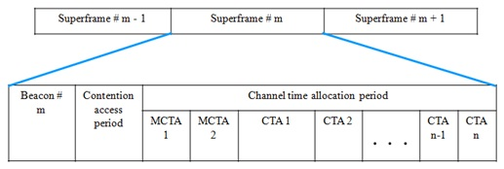
• The MCTAs are shown first, but the PNC is allowed to place any number of them at any position in the superframe.
Channel time is divided into superframe with
• Beacon: Contains piconet synchronization parameter and IE (Information Element)s
• CAP (Contention Access Period): Optional. For command frames and non-stream data. Using CSMA/CA with backoff scheme
• CFP (Contention Free Period): For data stream. PNC assigns to DEV with each CTA (Channel Time Allocation)
Q 41: Give the difference between GPSS and GPC.
Bandwidth Grant per Subscriber Station (GPSS)
• Base station grants bandwidth to the subscriber station
• Subscriber station may re-distribute bandwidth among its connections, maintaining QoS and service-level agreements
Bandwidth Grant per Connection (GPC)
• Base station grants bandwidth to a connection
• Higher overhead, but allows simpler subscriber station
Q 42: 8032.15.3 channel time division.
Channel time management
• There are three methods for communicating data between DEVs in the piconet:
1. Sending asynchronous data in the CAP, if present.
2. Allocating channel time for isochronous streams in the CTAP.
3. Allocating asynchronous channel time in the CTAP.
Dynamic channel selection
• Due to ISM bands, piconet is subject to interference from unlicensed users or other 802.15.3 piconets
• PNC has the capability to dynamically change the channel that the piconet is using without requiring either user intervention or the disruption of services in the piconet.
• To evaluate the status of the current channel as well as other channels, the PNC is able to use many methods including:
1. Gathering information about the current channel from other DEVs in the piconet using the Channel Status Request command.
2. Performing a passive scan of the channels.
3. Requesting other DEVs to perform a channel scan using the Remote Scan Request command,
Q 43: Give difference between Contention based and TDMA protocol.
• TDMA can easily avoid or reduce energy waste from all above sources
• Contention protocols needs to work hard in all directions
• TDMA has limited scalability and adaptivity
Hard to dynamically change frame size or slot assignment when new nodes join
Restrict direct communication within a cluster
• Contention protocols easily accommodate node changes and support multi-hop communications
Q 44: Give the difference b/w WMN and MANET.
WMNs are considered ad hoc due to lack of infrastructure (AP/BS).Although ad hoc techniques like MANET are required but WMNs require more sophisticated algorithms and design principles. And WMN diversifies the capabilities of ad hoc that makes MANET subset of WMNs
Following differences will illustrate it more
Wireless Backbone | Mesh routers as wireless backbone providing more coverage, connectivity and robustness. Individual nodes are routers in MANET making unreliable.
Integration | Supports client that use the same radio technology. Which is accomplished through host-routing function available in mesh router. Users of one network can enjoy services of other network
Dedicated routing and configuration | In MANET, each host perform routing and configurations which is done by mesh routers in WMNs. Hence decreasing load on end-user
Multiple radios | Two radios; one for routing and configuration functionalities between mesh routers. Second radio for network access by end users. These are performed on same channel in MANET. This significantly improves the performance
Mobility | Hosts also working as router in MANET make it more challenging, where the mobility of mesh routers is very limited

Q 45: By diagram show interspacing SIFS, PISF, DIFS and AIFS.
• Short interframe space (SIFS): The SIFS is used for the highest-priority transmissions, such as RTS/CTS frames and positive acknowledgments.
• PCF interframe space (PIFS): The PIFS is used by the PCF during contention-free operation. Stations with data to transmit in the contention-free period can transmit after the PIFS has elapsed and pre-empt any contention-based traffic
• DCF interframe space (DIFS): The DIFS is the minimum medium idle time for contention-based services. Stations may have immediate access to the medium if it has been free for a period longer than the DIFS.
• Extended interframe space (EIFS): The EIFS is not a fixed interval. It is used only when there is an error in frame transmission.
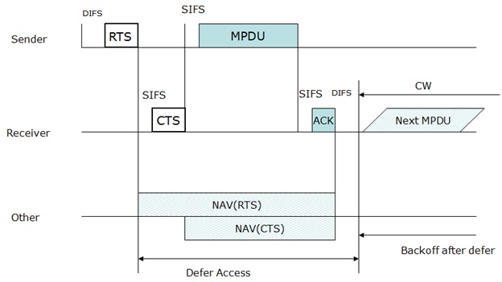
Q 46: Messages distribution in ESS.
Two services involved in distribution of messages within DS.
Distribution
• Primary service used to exchange MAC frames between stations of two
• Source sends to AP of one BSS, which sends to DS. DS then sends destination.
• Message transport in DS is beyond the scope of IEEE 802.11 standard.
Integration
• Enables transfer of a data between a station on an IEEE 802.11 LAN integrated IEEE 802.x LAN (Wired LAN).
• It takes care of any address translation and media conversion logic
Q 47: What is ZigBee Protocol? Explain the diagram of routing in zigbee?
What is ZigBee Alliance?
• An organization with a mission to define reliable, cost effective, low-power, wirelessly networked, monitoring and control products based on an open global standard
• The alliance provides interoperability, certification testing, and branding.
IEEE 802.15.4: What is ZigBee?
• A standard for mesh networking: reliability through meshed connectivity
• Designed for low power applications: rery long battery life
• Low data rate:20-250Kb/sec (depending on band)
• Very Secure: AES-128 encryption available
• Self configuring: allows ad hoc networks, ease of installation and configuration
Q 48: Bluetooth core specification and profile specification?
Core specifications
• Details of various layers of Bluetooth protocol architecture
• Bluetooth is a layered protocol architecture
Core protocols
Cable replacement and telephony control protocols
Adopted protocols
Profile specifications
• Use of Bluetooth technology to support various applications
Q 49: What is Piconet? it support minimum number of devices?
Piconet Structure
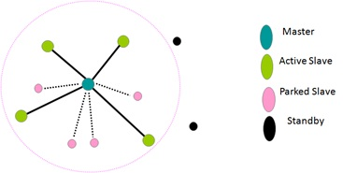
• All devices in piconet hop together.
• Master’s ID and master’s clock determines frequency hopping sequence & phase.
• Hopping sequence shared with all devices on piconet
• Bluetooth devices use time division duplex (TDD)
• Access technique is TDMA
• FH-TDD-TDMA
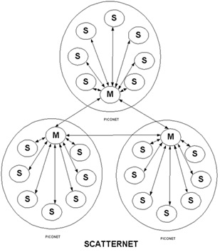
Ad-hoc Network – the Scatternet
• Inter-piconet communication
• Up to 10 piconets in a scatternet
• Multiple piconets can operate within same physical space
• This is an ad-hoc, peer to peer (P2P) network
Q 50: Why TCP protocol is not suited for WSN?
• Higher overheads for short data transmissions.
• Flow and congestion control cause unfair bandwidth for farther nodes.
• Throughput degrades under wireless due to higher packet losses.
• End-to-end congestion needs longer time to mitigate congestion, causing more congestion to occur.
• End-to-end reliability consumes more energy and bandwidth than hop-by-hop.
• Packet-based reliability, which is not required for event-driven applications
Q 51: What are the power saving techniques in High rate WPAN?
tandard provides three techniques to enable DEVs to turn off for one or more superframes:
Device synchronized power save (DSPS) mode
Piconet-synchronized power save (PSPS) mode
Asynchronous power save (APS) mode.
PSPS
• PSPS mode allows DEVs to sleep at intervals defined by the PNC.
• The DEV sends a request to the PNC when it wants to enter the PSPS mode.
DSPS
• Besides allowing the DEVs to wake up and exchange traffic at the same time, the use of DSPS sets makes it easy for other DEVs in the piconet to determine exactly when a DSPS DEV will be available to receive traffic.
APS
• The only responsibility of a DEV in APS mode is to communicate with the PNC before the end of its ATP in order to preserve its membership in the piconet.
Q 52: Which QoS classes are defined in WiMAX? Write the possible application and their related parameters to specify QoS.
QoS Category | Applications | QoS Specifications
UGS  Unsolicited Grant Service | VoIP | • Maximum Sustained Rate  • Maximum Latency Tolerance  • Jitter Tolerance
rtPS  Real-Time Polling Service | Streaming Audio or Video | • Minimum Reserved Rate  • Maximum Sustained Rate  • Maximum Latency Tolerance  • Traffic Priority
ErtPS  Extended Real-Time Polling Service | Voice with Activity Detection (VoIP) | • Minimum Reserved Rate  • Maximum Sustained Rate  • Maximum Latency Tolerance  • Jitter Tolerance  • Traffic Priority
nrtPS  Non Real-Time Polling Service | File Transfer Protocol (FTP) | • Minimum Reserved Rate  • Maximum Sustained Rate  • Traffic Priority
BE  Best-Effort Service | Data Transfer, Web Browsing, etc. | • Maximum Sustained Rate  • Traffic Priority

Q 53: In WSN what are the 3 MAC , 4 Routing and 3 transport protocol types.
Q 54: TCP time issues in TCP.
Q 55: Which protocol is used in WMSN?
Q 56: Why do we need broadband wireless access , architecture diagram of Wimax
Q 57: In Bluetooth, a device can be associated in two piconets at the same time. Is there any reason why one device cannot be the master in both of them at the same time?
Q 58: Why IEEE 802.11 standard cannot be used for broadband wireless MAN and needed to develop a new standard IEEE 802.16?
Q 59: Categorize and discuss the basic types of traffic data access in WCDMA.
Q 60: Mobile IP was intended to work with legacy correspondent hosts and legacy applications. However, some advantages may be gained if correspondent hosts are aware of mobility in certain ways.
Q 61: If a correspondent host is able to do IP-in-IP decapsulation, it may be able to communicate more efficiently with the mobile host despite the presence of ingress filtering. Why?
Q 62: If a correspondent host is able to maintain a mapping between a mobile host’s local IP address and its home IP address, and receive updates to that mapping from the mobile host, it may be able to communicate more efficiently with the mobile host than is possible with standard Mobile IP. Why?

